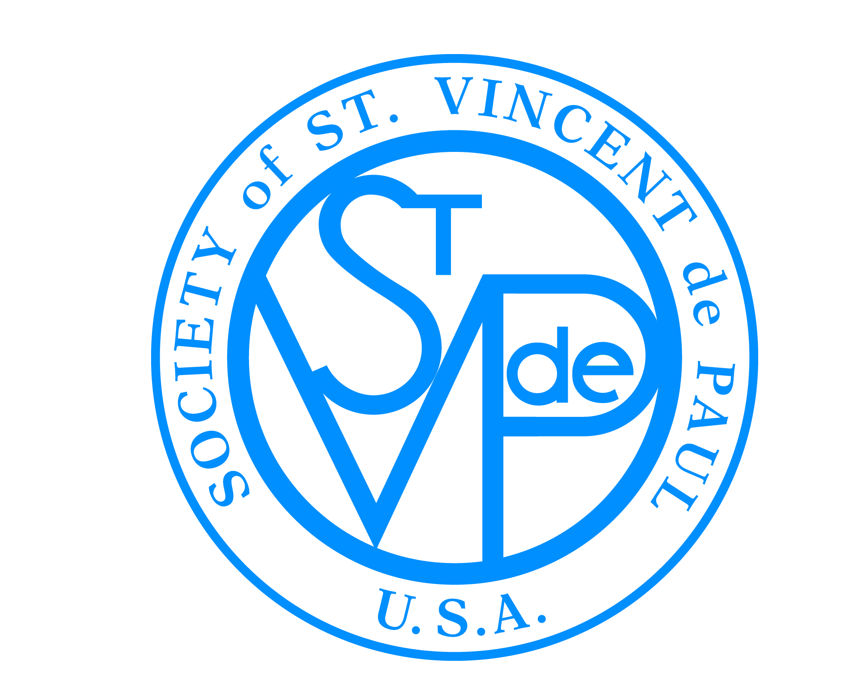

FRIENDS OF THE POOR® WALK/RUN
SOCIETY OF ST. VINCENT DE PAUL
®

Dear Friend,

Day after day, many people in our very own community struggle to make ends meet. To help with this, the Society of St. Vincent de Paul in Maryland Heights, St. Richard Conference, is helping individuals and families in our community. Every day, SVdP volunteers work with families to provide emergency food, help keep the lights on, and avoid eviction. SVdP volunteers continuously work to provide individuals and families with assistance regardless of religion, race, or national origin.

The Friends of the Poor® Walk is a national special event that was started eight years ago to raise awareness and funds for the Society of St. Vincent de Paul. We will be joining 240 other Friends of the Poor® Walks across the United States in an effort to eradicate poverty.

Would you please consider becoming a sponsor for our Annual Friends of the Poor® Walk scheduled for Saturday, September 30, 2017?

This year’s walk will take place at the Westport Plaza Lake, and we would greatly appreciate your support! To ensure you receive proper recognition, please return the enclosed sponsorship form by August 1st, 2016. Thank you!

Sincerely,

Dale Johnson
St. Richard Conference President

The Society of St. Vincent de Paul is a registered 501c3.
Donations are tax deductible to the fullest extent allowed by law.

