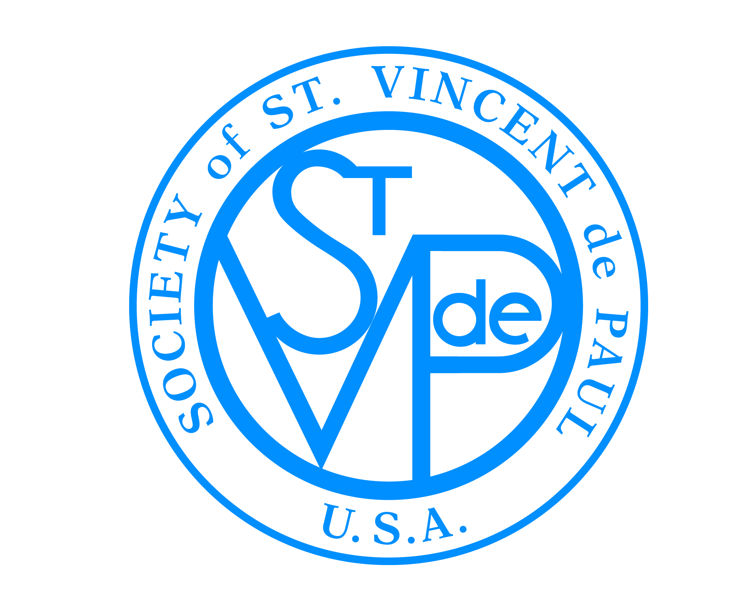

FRIENDS OF THE POOR® WALK/RUN
SOCIETY OF ST. VINCENT DE PAUL
®

Media Talking Points

- The Society of St. Vincent de Paul is one of the oldest and most effective charitable organizations in the world. It was founded in Paris, France in 1833. The United States Society of St. Vincent de Paul was founded in 1845, in St. Louis, Mo.

- Currently, 800,000 men and women provide person-to-person help to the poor in 150 countries on five continents.

- The Friends of the Poor Walk® began in 2008 to celebrate the 175th anniversary of the Society of St. Vincent de Paul (SVdP). This year, 2017, will be the 10th Annual Friends of the Poor® Walk/Runs across the country.

- Funds raised from the Walk help those in need with food, clothing, medicine, housing assistance, transportation and utility costs, job training and placement, and disaster relief.

- Those who receive help come from all kinds of ethnic and faith backgrounds.

- All proceeds from the Walk directly benefit people in the communities where the money is raised. There are no administrative fees associated with the event.

- The 2016 Walk was held at 240 locations around the country, attracted more than 28,000 participants, and raised more than $3.1 million.

- Each community’s Walk is organized and run by its own SVdP Conference or Council.

- St. Vincent de Paul was born of poor parents in the late 1500’s, and is now the patron saint of charitable causes.

