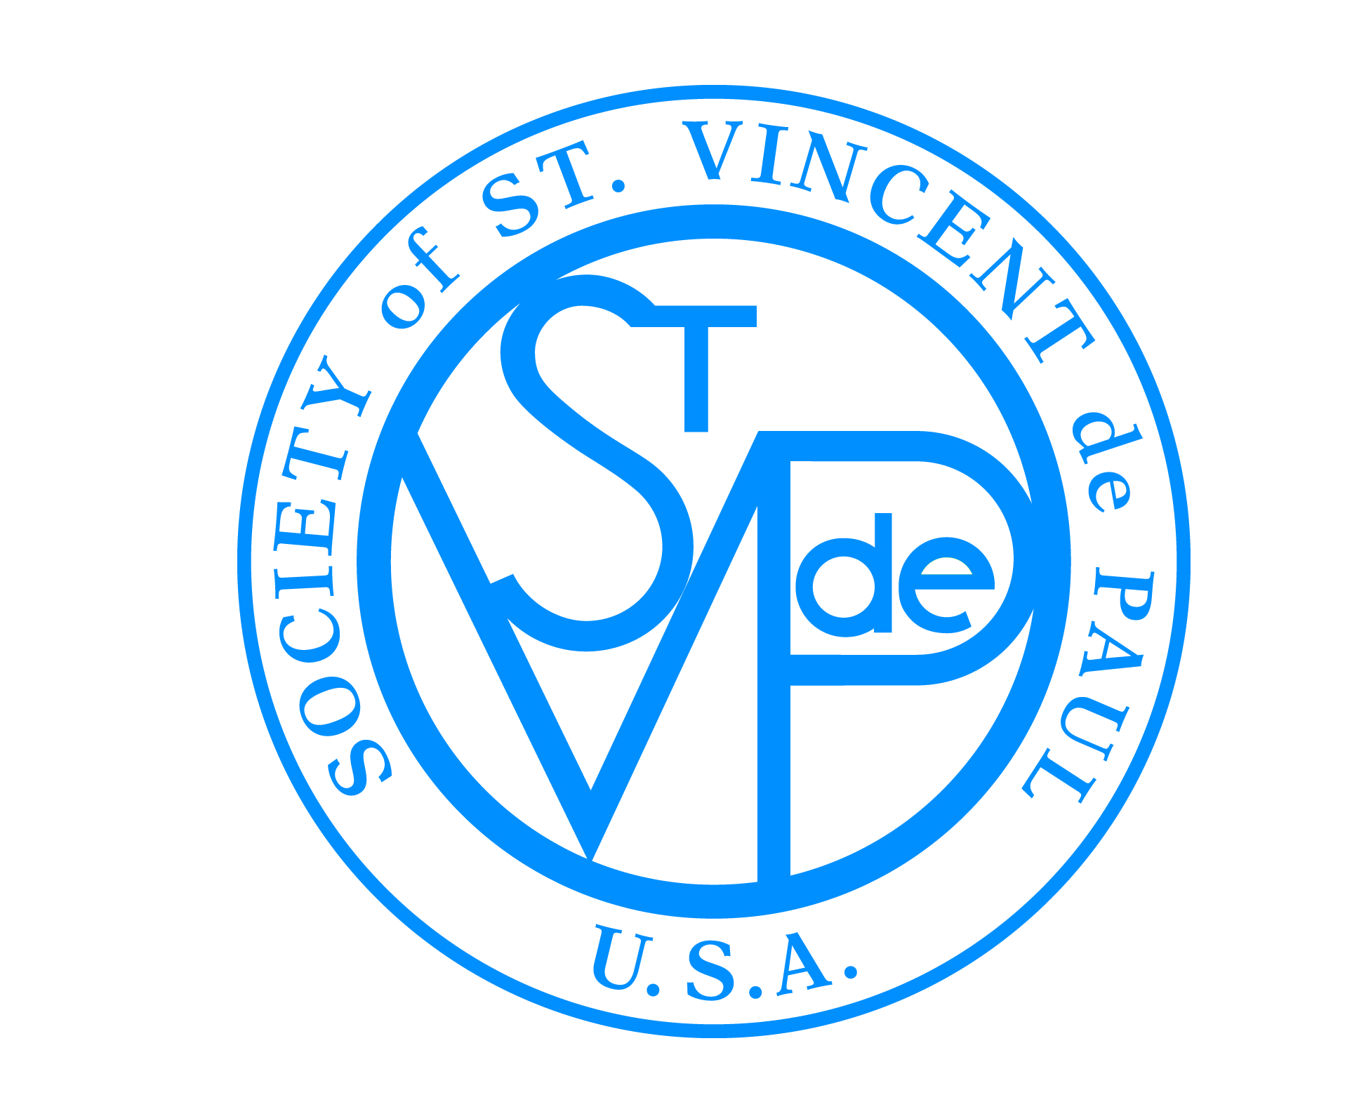

FRIENDS OF THE POOR® WALK/RUN
SOCIETY OF ST. VINCENT DE PAUL
®

Final Report Form

Each walk location coordinator is responsible for collecting the totals from all participating Conferences, and then filling out one report form. The report form is due by October 15, 2018, and should be submitted to:

Nathan Martin
nmartin@svdpusa.org
314-576-6755 (Fax)
58 Progress Parkway
Maryland Heights, MO 63043

Conference/Council Name:
City/State:
Walk/Run Location:
Prepared By:
Contact Phone:
Total Number of Walkers/Runners | Walker/Runner Offline Revenue |  | Corporate Sponsor Offline Revenue |  | Total Offline Dollars Raised

Suggestions for the National Council Office to improve this event: ______________________________________________________________________________________________________________________________________________________________________________________________________________________________________________________________________________________________________________________________________________________________________________________________________

