Facebook posts:

Be sure to save the picture under each post as a .jpg picture, to be uploaded with the post on Facebook. Then, copy and paste the post’s wording onto your Facebook page, then attach the saved picture.

Facebook Post #1

Ever wonder how you can make a difference for those in your community? Mark your calendars for Saturday, September 28, 2019, and join your friends and neighbors at the Annual Friends of the Poor® Walk/Run, sponsored by the Society of St. Vincent de Paul. For more information, or to register as a walker, please check out our events page at www.fopwalk.org.
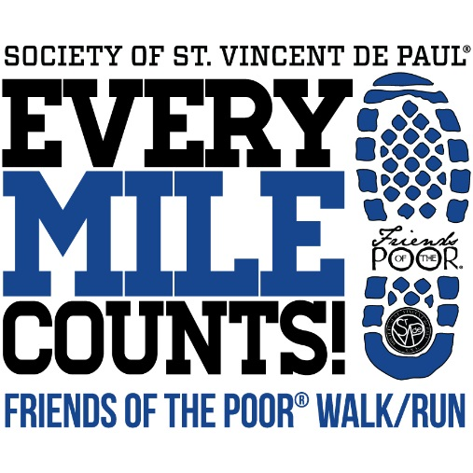

Facebook Post #2

Have you signed up for the Annual Friends of the Poor® Walk on Saturday, September 28, 2019? All money raised will go to the Society of St. Vincent de Paul, so they can provide direct service to those in need locally. To register as a walker, or get additional information, please check out our event page at www.fopwalk.org.
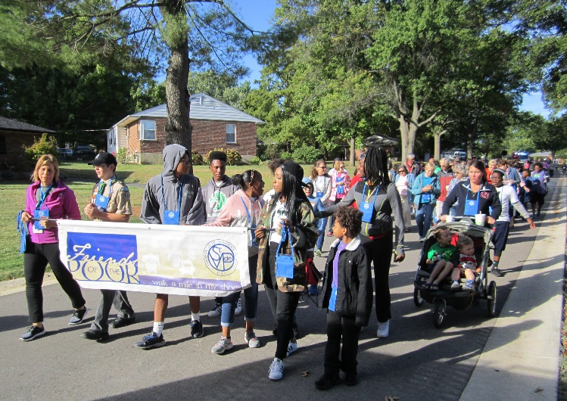

Facebook Post #3

Are you willing to help those in need? One easy way to help those living in poverty is by supporting the Annual Friends of the Poor® Walk held by the Society of St. Vincent de Paul. Held on Saturday, September 28, 2019, this event raises funds and awareness for those living in need. All proceeds from this event will go to helping people in our very own community. Please register to walk at www.fopwalk.org.

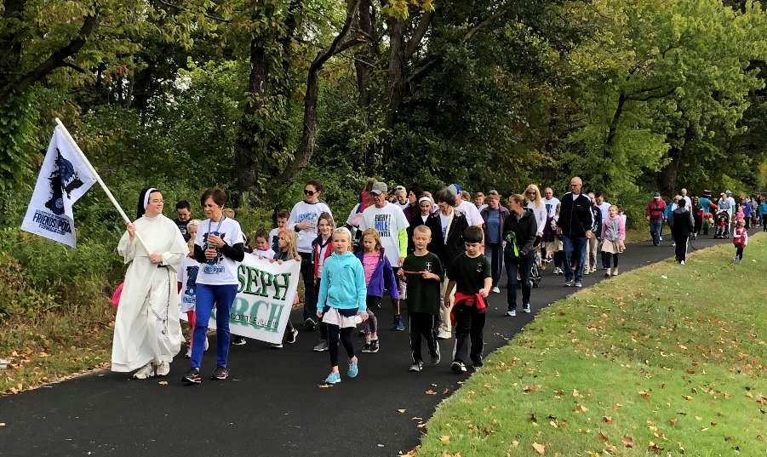

Facebook Post #4

Every Mile Counts! When we walk, we make a difference. All proceeds raised for the Friends of the Poor® Walk will stay local, to help those living in poverty. To walk, sponsor, or donate, please go to www.fopwalk.org.

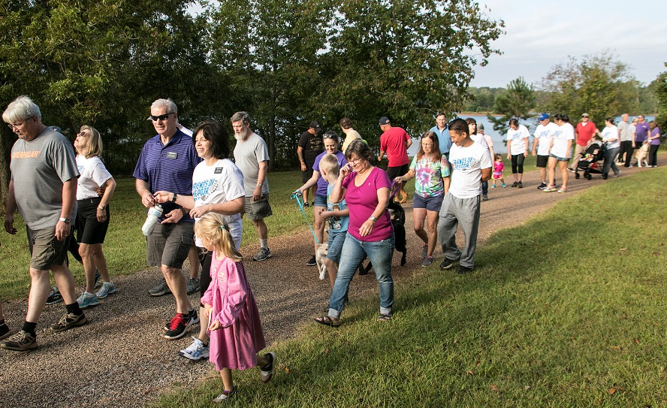

Facebook Post #5

The 2019 Friends of the Poor® Walk is approaching fast! However, it’s not too late to get involved. By registering to walk, or donating today, you are helping those in poverty. To learn more about this event, please go to www.fopwalk.org.

